

**Excel Assignment - 9**

1. What are the different margins options and do we adjust the margins of the excel worksheet?

Ans: There are three margins : Normal, Wide, Narrow and other is custom that we can customized as per our need. Yes we adjust the margins as pe the Sheet adjustment and we can also adjust for the print purpose.

1. Set a background for your table created.

Ans: 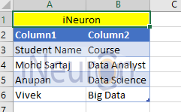

1. What is freeze panes and why do we use freeze panes? Give examples.

Ans: Freeze panes is that which keep the area of selected column and rows visible while scrolling to another area in worksheet.

We use the freeze panes when we have huge amount of data with multiple headers and we want to see the records along with headers.

1. What are the different features available within the Freeze Panes command?

Ans: In Freeze Panse command we can use the Freeze Top raw and Freeze First Column features also

We can Go To View ribbon then Freeze option will show and Short cut key- Alt W+F.

1. Explain what the different sheet options present in excel. and what they do?

Ans: Excel allows us to organize multiple sheets in single workbook, and by default it contain one sheet,

Here are different sheet options:-

Inserting new worksheet

Renaming worksheet

Moving and copying worksheet.



?